Pittsburgh Traffic Accidents: Spatial, Temporal, and Weather-Related

Figure & Legend
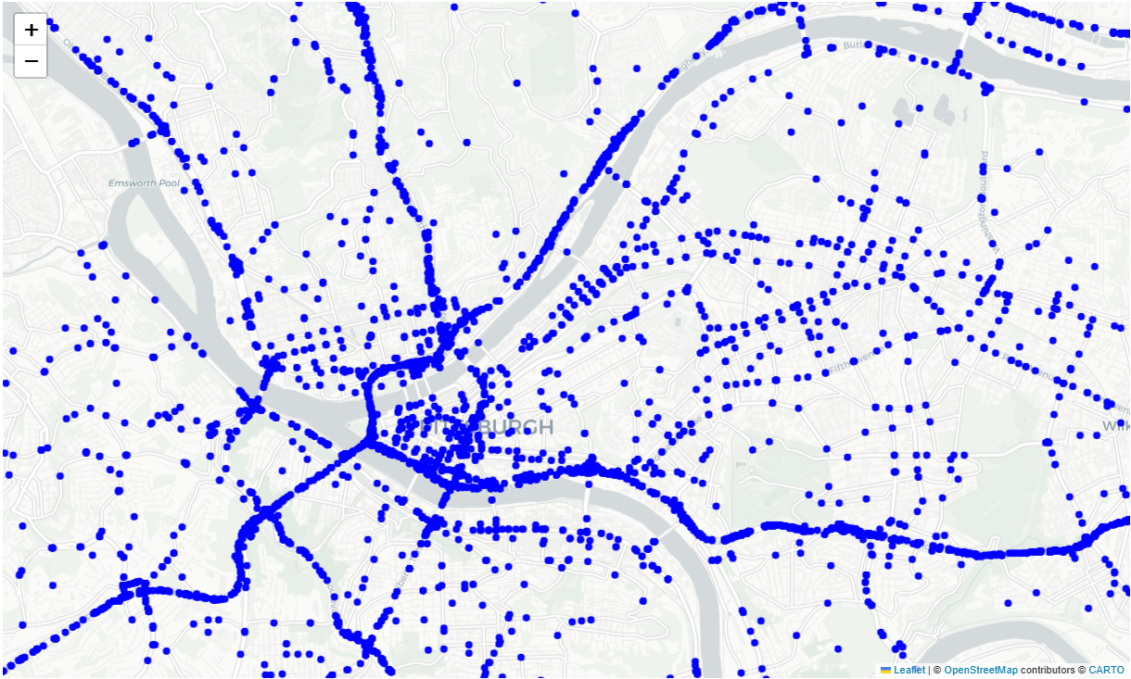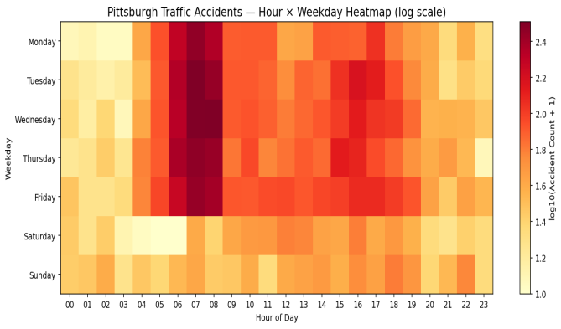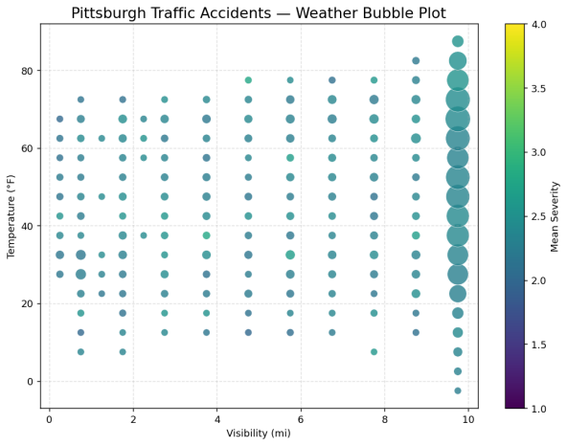

Findings
Main Figure(Spatial dot Map):
Accident points cluster densely along major corridors such as I-279, I-376, and Route 28, indicating these are high-risk commuter routes.
The highest concentration occurs around Pittsburgh Downtown, especially near bridges and highway junctions, hinting at ramp merging and high traffic pressure as contributing factors.

Temporal Heatmap:
A strong morning peak between 6–9 AM on weekdays, matching Pittsburgh’s inbound commuting patterns. Weekend patterns flatten significantly, showing dramatically lower accident intensity during typical work commute hours.

Weather Bubble Plot:
Severity is relatively stable across temperature ranges but get a little worsens under cold temperatures (20–40°F) combined with low visibility conditions — possibly due to snow or ice.

Very high severity cases appear disproportionately under foggy and low-visibility conditions.

Data and Method
Dataset: US Accidents (2016–2023), a 2.8 GB large-scale national accident dataset from Kaggle

Fields used:
Geographic: Start_Lat, Start_Lng, City, State
Time: Start_Time
Weather: Visibility(mi), Temperature(F), Severity

Pre-processing:
Restricted to Pittsburgh, PA, using State == "PA" and City == "Pittsburgh".
Data loaded using chunksize = 200,000 to handle large file efficiently.
Start_Time converted to datetime and binned into weekday × hour.
Visibility and temperature binned into meaningful ranges (0.5 mi / 5°F intervals).

Visualization Methods
Spatial Point Map
Accident records were geocoded using their precise latitude–longitude coordinates and rendered as high-density point distributions over Pittsburgh’s road network. This visualization highlights spatial clustering and corridor-level concentration patterns.

Temporal Heatmap
Accident timestamps were decomposed into weekday and hour components and aggregated into a 7×24 matrix. A log-transformed heatmap was applied to reveal temporal rhythms and commuting-related peaks.

Weather Bubble Plot
Weather variables were discretized into visibility and temperature bins. For each bin, accident frequency and average severity were computed and encoded jointly through bubble size (frequency) and color (severity), enabling multivariate pattern detection under different environmental conditions.

Significance Statement
Traffic accidents are a major public safety concern, and Pittsburgh’s unique geography — rivers, tunnels, bridges, and dense highway networks enlarge these risks.
By visualizing accidents at spatial, temporal, and weather-related levels, this study reveals patterns that are invisible in raw data alone, enabling clearer insights into the causes and contexts of traffic risk. Which may help us improving urban transportation planning, designing data-informed safety interventions and improve roadway safety

